STOCK MARKET PREDICTION

# 1.1.2. Development phase/reflection phase

**Abstract**

The goal is to predict the stock price movements with the help of pre-processing approaches that include time series decomposition, fixed rolling windows, and others possibly containing a high degree of sophistication. Holt’s Linear Method, and subsequently to the Holt-Winters Method and finally to seasonal moving average and seasonal moving total integrated to ARIMA, and SARIMA models and fine-tuned for accuracy for preliminary estimation Naive and Average.

## Introduction

The project aims to predict stock closing prices using time-series analysis, addressing the challenge of accurate forecasting in financial markets with historical data from Yahoo Finance

## Related work

Previous research Wang,and Alexander,2020 demonstrated the effectiveness of various time-series models, such as ARIMA and Holt-Winters, in forecasting stock prices with notable accuracy.

## Technical background

The problem leverages time-series analysis techniques such as decomposition, rolling windows, and advanced models such as Holt’s Linear, ARIMA, and SARIMA to analyze historical stock price data and forecast future trends and fluctuations accurately.

## Method

The method of this process is to estimate or predict fluctuations within stock prices by employing techniques such as breaking down time series data, using fixed rolling windows, as well as complex algorithms for forecasting. The first is cleaning and visualization of the data as well as evaluating the variation of stock prices through regular pattern, random variation, and seasonality.

## Implementation

The solution leverages the power of Python to clean and analyze stock data , as well as employing time series decomposition, rolling window analysis and other statistical and machine learning modeling techniques for accurate prediction of stock price trends in the future.

## Testing

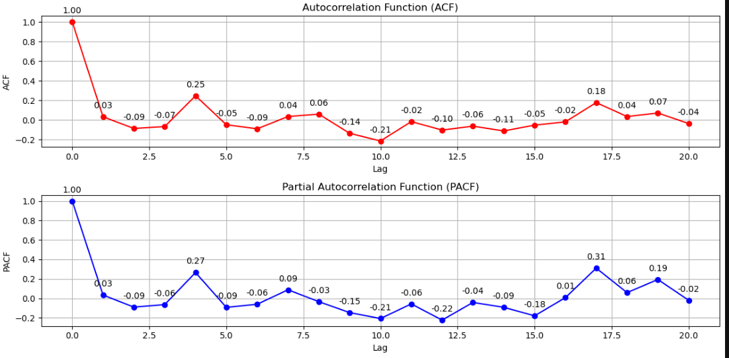

**Figure 1: Autocorrelation function(ACF) and Partial autocorrelation function (PACF)**

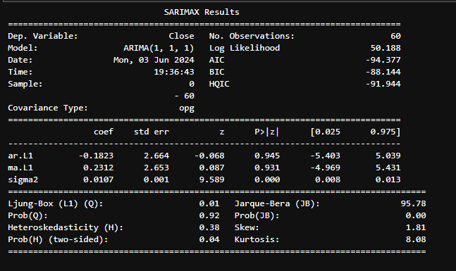

**Figure 2: ARIMA forecast metrics**

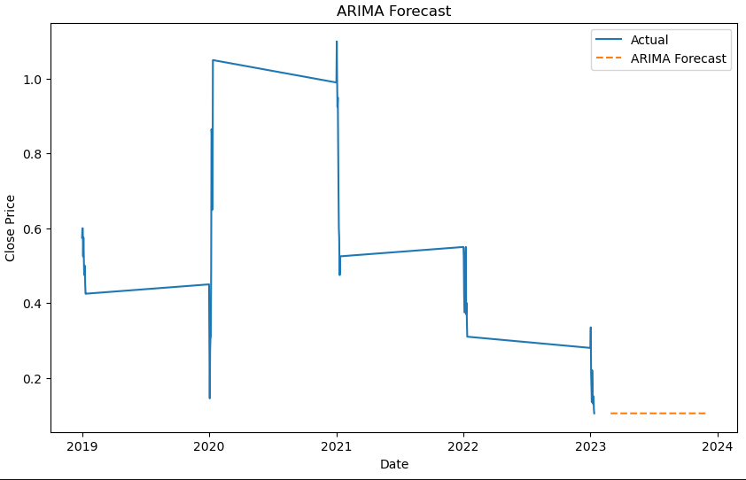

**Figure 4: ARIMA forecast**

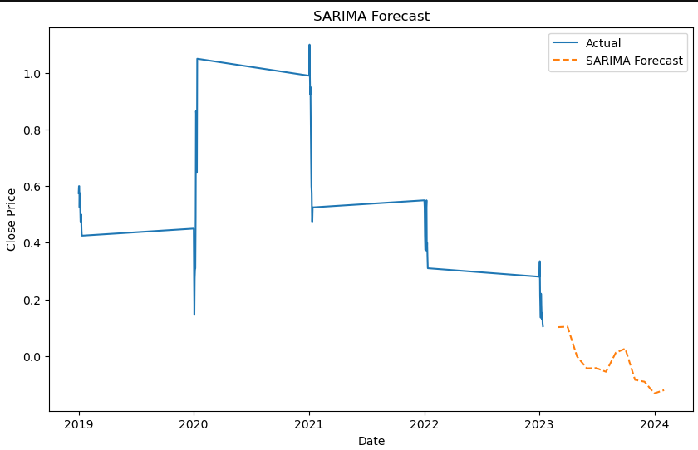

**Figure 5: SARIMA forecast**

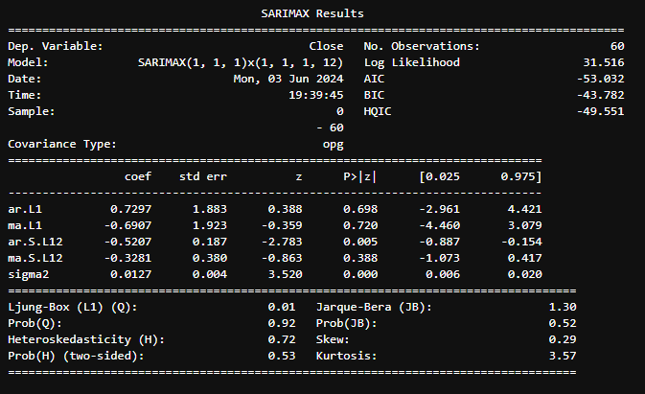

**Figure 6: SARIMA forecast metrics**

## Conclusion

Visualisation used are “Moving Average (Single, Linear, Winters), Auto-Regressive Integrated Moving Average (ARIMA) and Seasonal Auto-Regressive Integrated Moving Average (SARIMA)”. The use of SES method found to overestimate the actual values but with the help of approach the trend and fluctuation of stock price and seasonality found easily. It is established that the usage of the improved time series tools is possible when it comes to the incorporation of the stock marketing price forecasting cover that can describe the major shifts and seasonal aspects in the context of the stock prices.

## Bibliography

Wang, L. and Alexander, C.A., 2020. Big data analytics in medical engineering and healthcare: methods, advances and challenges. Journal of medical engineering & technology, 44(6), pp.267-283.

Li, W., Chai, Y., Khan, F., Jan, S.R.U., Verma, S., Menon, V.G., Kavita, F. and Li, X., 2021. A comprehensive survey on machine learning-based big data analytics for IoT-enabled smart healthcare system. Mobile networks and applications, 26, pp.234-252.